1. Which are the top three variables in your model which contribute most towards the probability of a lead getting converted?

Ans: The top 3 Variable that contribute most towards the probability of a lead getting converted is depicted as per the below graph.

* Tags_Lost to EINS
* Tags_Closed by Horizzon
* Tags_Will revert after reading the email

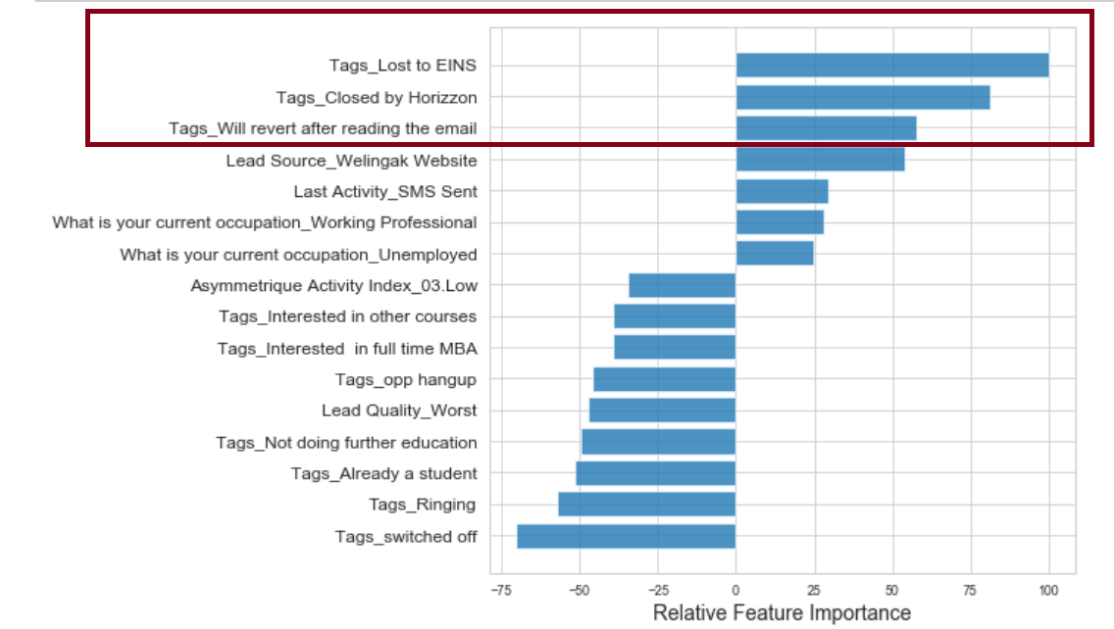

1. What are the top 3 categorical/dummy variables in the model which should be focused the most on in order to increase the probability of lead conversion?

Ans: The top 3 categorical/dummy variables which get maximum focus in order to increase the probability of lead conversion are also the same 3 as above.

* Tags_Lost to EINS
* Tags_Closed by Horizzon
* Tags_Will revert after reading the email

1. X Education has a period of 2 months every year during which they hire some interns. The sales team, in particular, has around 10 interns allotted to them. So during this phase, they wish to make the lead conversion more aggressive. So they want almost all of the potential leads (i.e. the customers who have been predicted as 1 by the model) to be converted and hence, want to make phone calls to as much of such people as possible. Suggest a good strategy they should employ at this stage.

Ans: **Sensitivity** of our model is defined as the **ratio of total number of actual Conversions correctly predicted to the total no of actual Conversions**.

**Specificity** is defined as the **ratio of total no of actual non-Conversions correctly predicted to the total number of actual non-Conversions**.

For a model, **as one increases, the other decreases and vice versa**.

Different sensitivity and specificity is got for the same model by changing the Conversion Probability cutoff threshold value.

The below graph shows the way Sensitivity and Specificity rate changes with threshold value change:

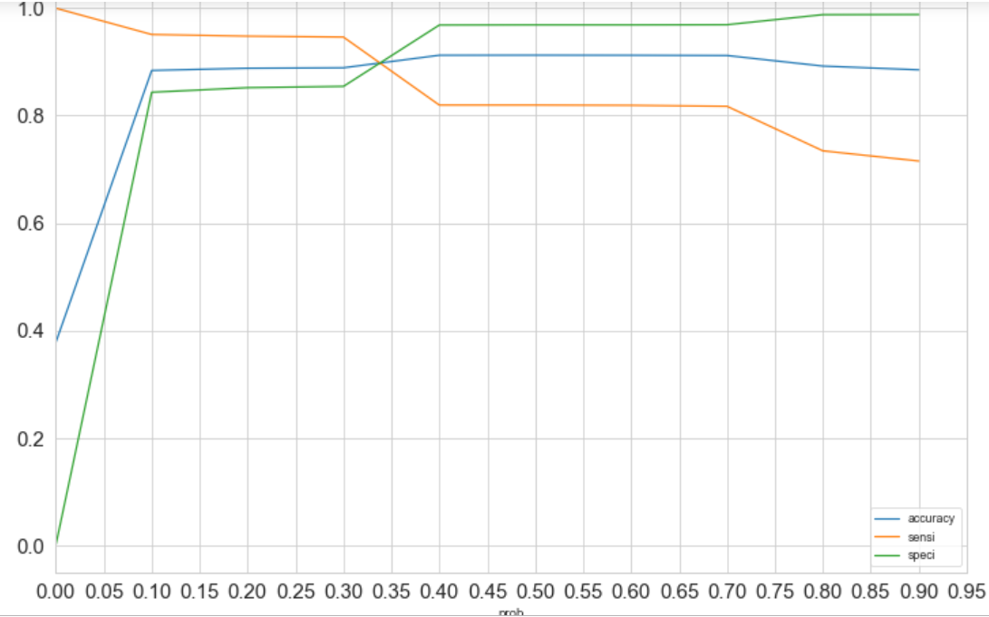

For instances when the probability thresholds are low, the sensitivity is pretty high and specificity is quite low. On the same lines, in case of larger probability thresholds, the sensitivity is seen to be quite low but the specificity is observed to be high.

High sensitivity means that our model will correctly identify most leads that are likely to Convert.

Since X Education has high man-power for the 2 months and wish to make the lead conversion more aggressive by expecting almost all of the potential leads, we decide to choose a lower threshold value for Conversion Probability.

This will promise the Sensitivity rate is very high which in turn will have a check on almost all leads that are likely to Convert are identified correctly and the agents can make phone calls to as much of such people as possible.

1. Similarly, at times, the company reaches its target for a quarter before the deadline. During this time, the company wants the sales team to focus on some new work as well. So during this time, the company’s aim is to not make phone calls unless it’s extremely necessary, i.e. they want to minimize the rate of useless phone calls. Suggest a strategy they should employ at this stage.

**Ans:** High Specificity tells us that our model will correctly identify most of the leads that are not likely to Convert.

As X Education has already reached its target for a quarter and doesn’t want to make phone calls unless it’s extremely necessary, i.e. they want to minimize the rate of useless phone calls, decision can be made to choose a higher threshold value for Conversion Probability.

This will make sure the Specificity rating is high, which in turn will make sure almost all leads that are on the sure of getting Converted or not are not selected. Hence the agents need not make further phone calls and can focus on some new work.